Working with Tasks that Link to the Activity BAND

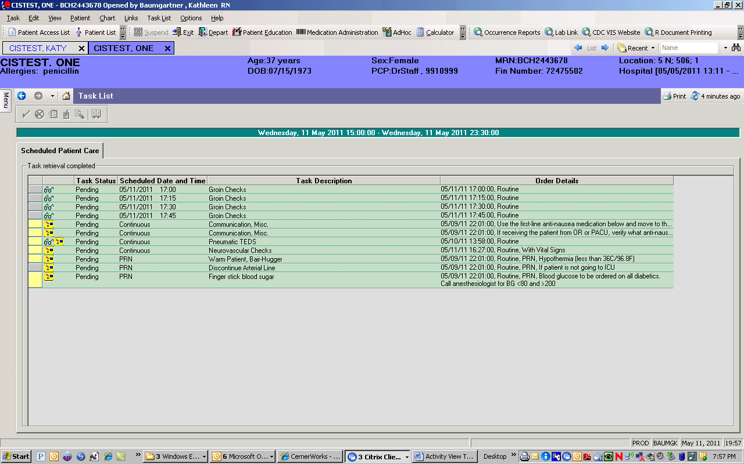

I want to chart on the 1700 task

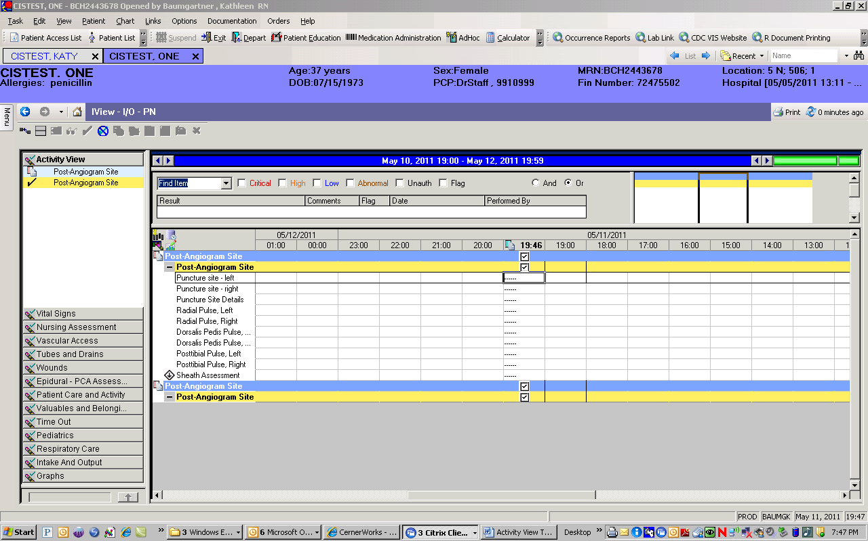

A current time column appears



But…I need a time column for 1700

So I will click on this new Icon

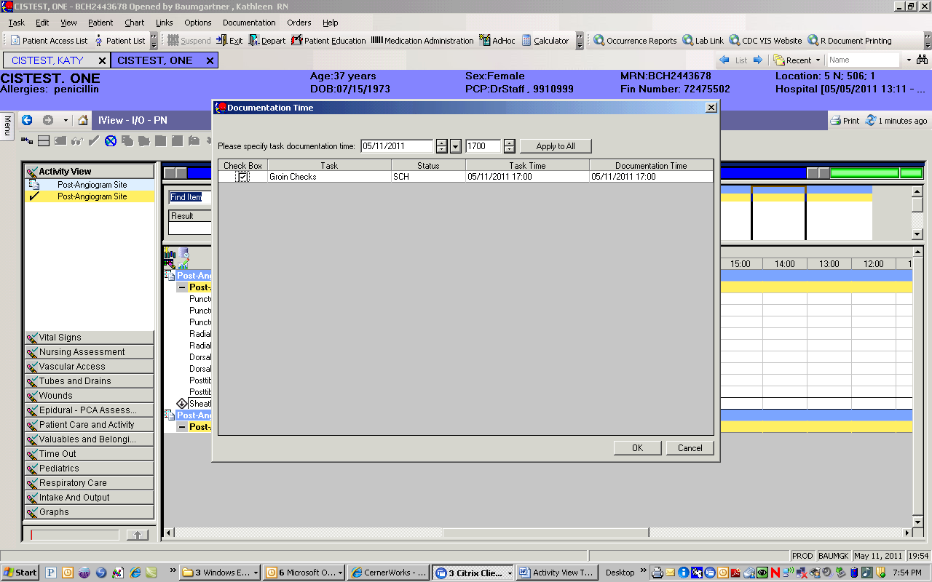

Fill in the time you need and ‘Apply All’