

Welcome to PowerChart Training!

CIS PORTION of SOAR

The following is an outline for the material that we will be covering in class.

RN/LPN

Rev. 3/2011

**Objectives**

This is an introductory class that will show you the basic functionality of documentation in Power Chart. At the end of these classes you will be able to:

* Document patient data
* View, modify, unchart data
* Navigate electronic chart
* Utilize barcode scanning technology

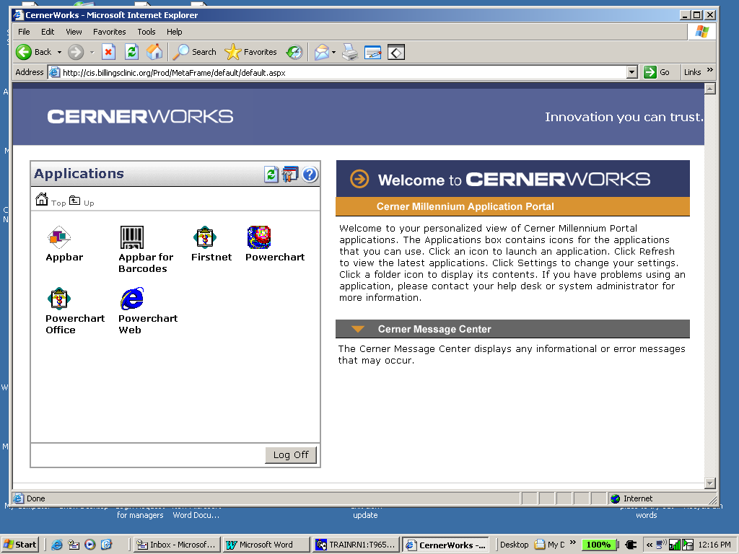

1) Logging in

First, double click on Icon

1. User name and password
2. **Protect your password!**

★Your name is attached to each chart

opened.

2) 3 ways to access a patient

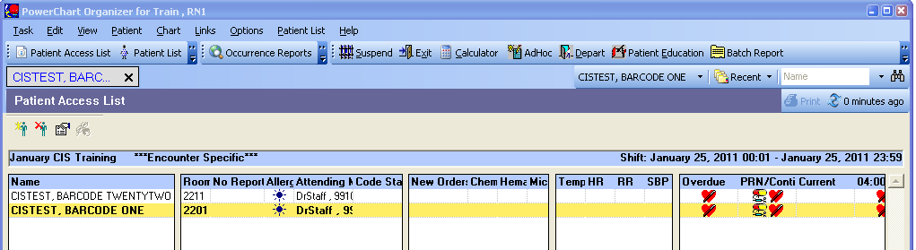 chart

1. Patient Access List (PAL)
2. Patient List
3. Search out patient

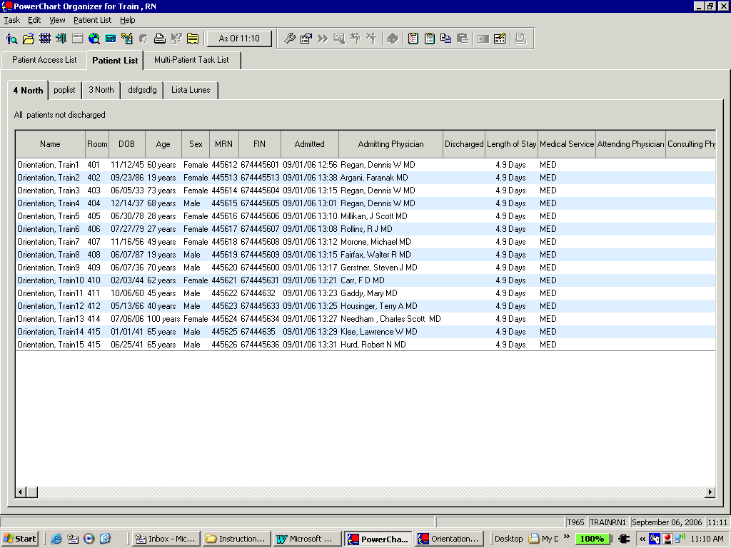3) Opening the patient chart

a) Double click on name

4) Searching for a Patient

1. When you click on the search icon, the Patient Search window opens up.
2. Type in the patient’s last name **or** their Financial Information Number (FIN #)

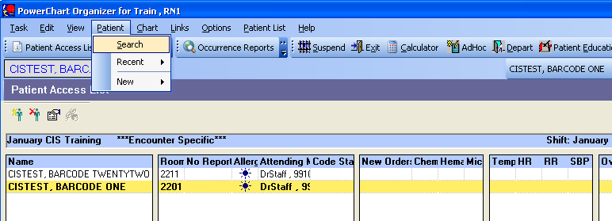

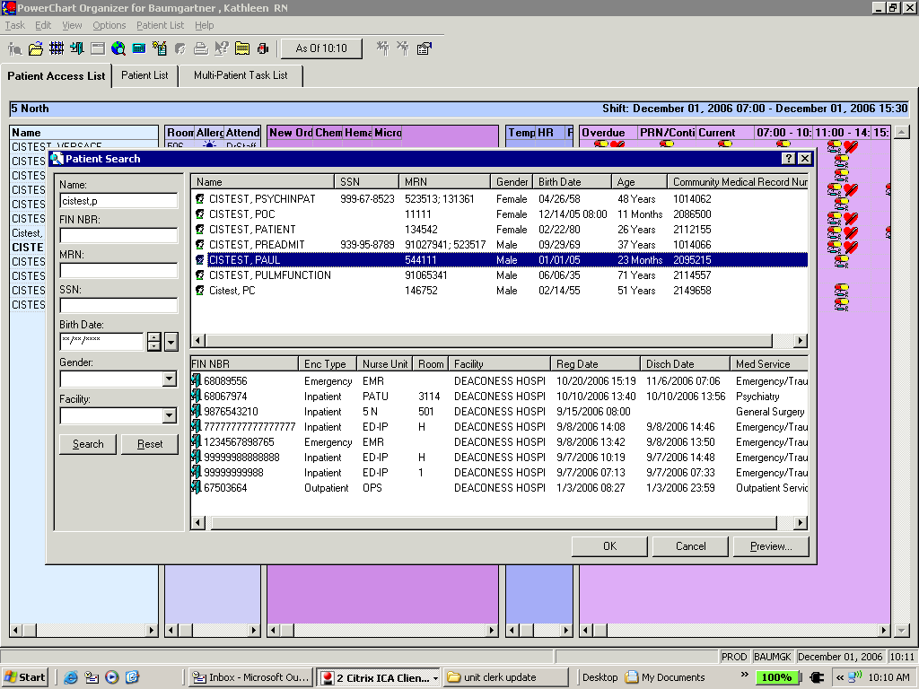

★**Do not select chart by**

**Clicking on patient name:**

This allows the system to

select a random encounter.

★Select the CORRECT inpatient encounter

from the **bottom half** of the screen.

*Note the lack of discharge date and*

*the word ‘Inpatient’ indicate a patient*

*currently in the hospital .*



5) Protecting the

Chart

a) Securing- use the

‘jail’

b) Exiting -use the ‘door’

★**Never walk away with a chart open!**

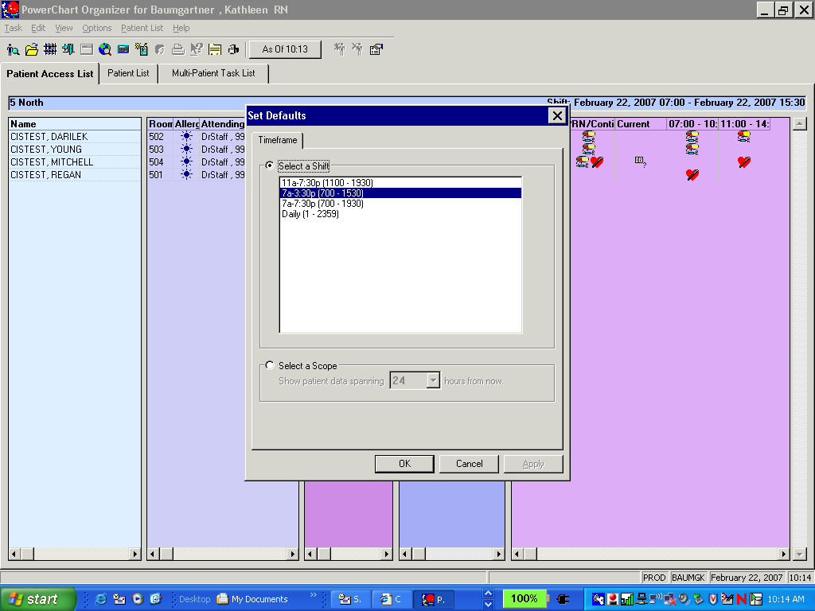

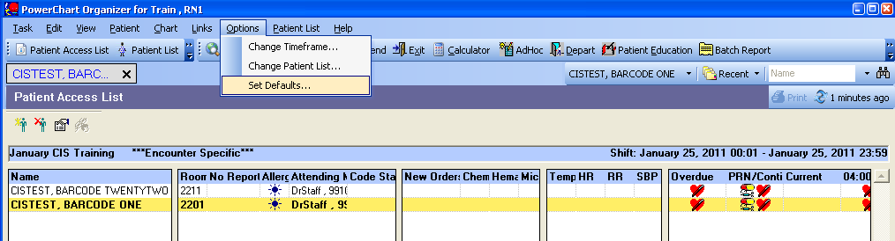6) PAL Time Default

a) Choose ‘Options’

b) Choose ‘Set Defaults’

c) Highlight the time

frame you desire.

d) Click on ‘OK’

NOTE: Night shift time frame does not show up until after 6pm.

7) The PAL is your organizational tool.

★**Check it often during your shift!**

1. Displays most recent labs and vitals.
   * 1. Hover over result with your mouse to see when value was taken.

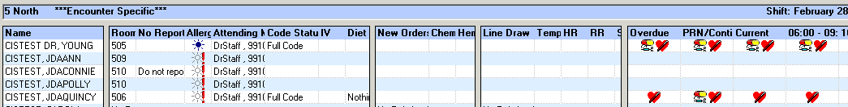

1. Overdue, PRN & Scheduled:
   * 1. Tasks (e.g. ambulate patient)
     2. Labs specimen collection (e.g. collect urine)
     3. Medications
2. 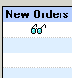New Physician orders

8) Establish Relationship box when opening the PAL:

a) **If you are not caring for those patients, do not establish a relationship with them!**

b) If you establish a relationship your name will be permanently attached to the patient charts that are check marked.

c) Click  at the bottom of the screen to not establish a relationship

d) If you do not establish a relationship with the patient, no information will

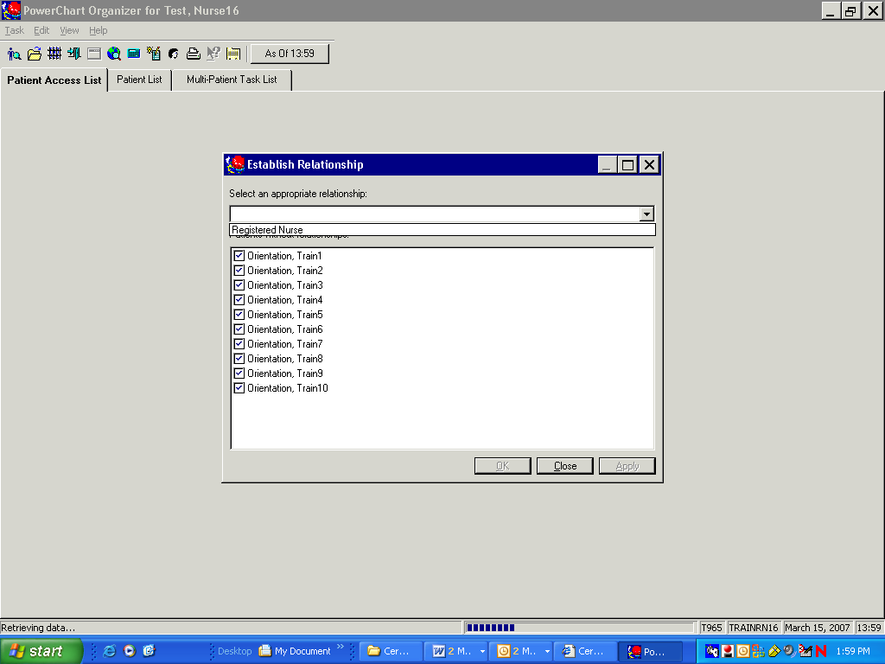 appear on your PAL.

9) Establishing a relationship

a) If you are caring for these patients, choose your title from the dropdown menu.

Click on the drop down menu and then double click on your job title. Then ‘OK’

b) Click 

9) Creating Patient Lists: must do from ‘Patient List’ not ‘PAL’

* 1. **Copying patients** onto your custom list.
     1. 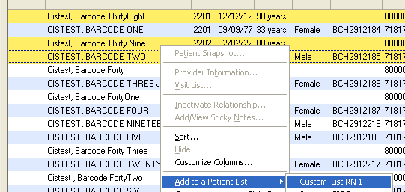You have control, so hold the ‘CTRL’ key on your keyboard down and use your mouse to highlight names.
     2. Right click on a yellow bar and choose “Add to Patient List”
     3. Choose your custom list
     4. Click your custom list tab
     5. Refresh
  2.  **Deleting patients** from your custom list. Use the ‘CTRL’ key and mouse highlight the names.

Then click.

Intake and Output (I&O)

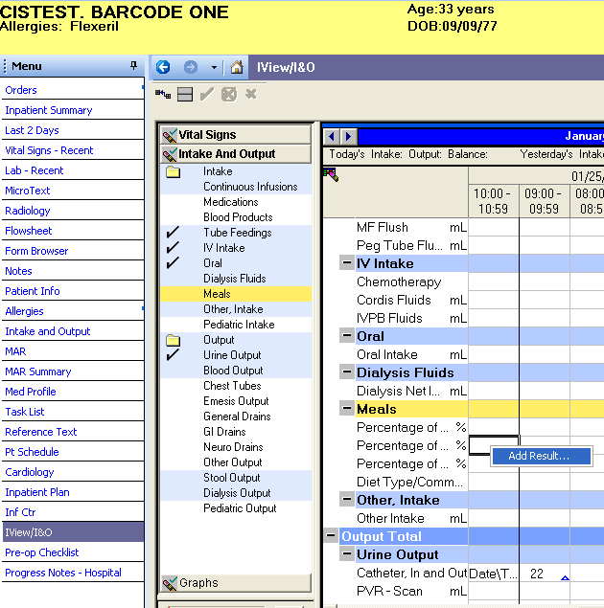

1. Location of Intake and Output
2. On the Menu click the
3. ‘I-View/I&O/PN’ tab
4. Click on the band
5. ‘Intake and Output
6. Charting I&O
7. Right click on the current time cell
8. Choose ‘Add Result’
9. Type in data
10. Hit ‘Tab’ key or click in another cell to turn the value purple
11. Click to sign your charting
12. 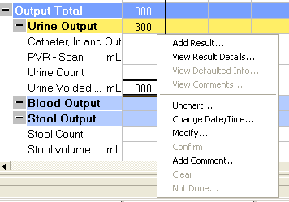Right Click for more options after adding a number.
13. Add result- if you need to add another value for the same time frame.
14. Choose Add result
15. Type in additional value & Hit Tab key
16. 
17. Sign your data 
18. Computer will automatically add results for you
19. 
20. Unchart- always add a comment when you unchart something
21. Modify- always add a comment when you modify something

★ **Comments tell the patients’ story**

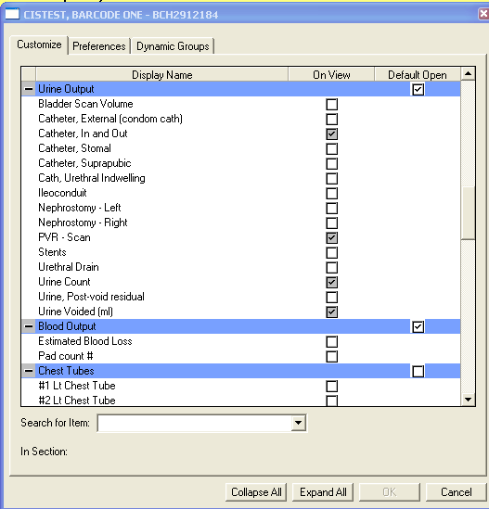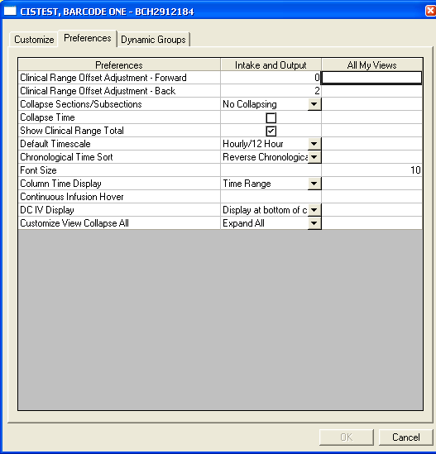Customize View & Preferences

* 1. The customize tab allows you to add sub-sections (eg. new drain or chest tube)
  2. The preferences tab allows you to change your personal I&O view.

Task List

* 1. This is your documentation of the tasks you did with your patient
  2. **Always** chart Point of Care Tasks (e.g. Finger Stick or Gauiac Stool) from task list.
  3. Date range bar: ensure correct time is selected.

If date/time range is incorrect, right click to change time range criteria

* 1. Yellow (no forms)/Grey boxes (forms to fill out)
  2. A right click on a task will give options

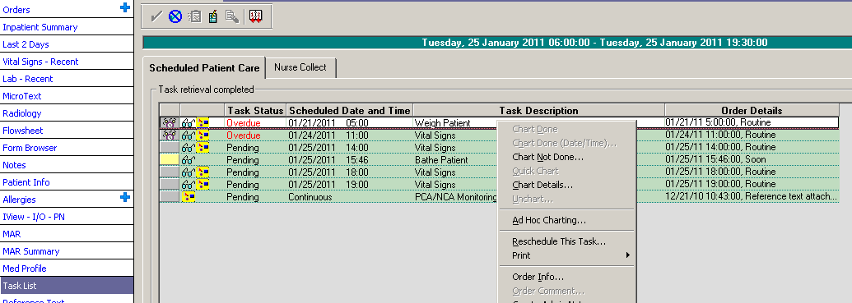

Right clicking on a task gives you these options

Nurse collect tab is where you will find any Lab specimens that need collected

Ad Hoc Charting You can chart Vital Signs here if there is no “Vital signs” on your task list.

***Never chart Point of Care (e.g. finger stick or guaiac stool) from Ad Hoc.***

***~Wait until you have a task to chart results.***

1. -First click on the icon on the task bar at the top of the screen
2. -Choose ( ) –or- ( )
3. -Next, place check mark(s) in the box(s)
4. Select 

Flow Sheet: This is where you see what you charted. If you are not seeing what you charted

* 1. ‘Refresh’ the screen with the ‘As Of'’ button.
  2. Next be sure your Flowsheet Filter is set to ‘All Results Flowsheet’.
  3. Lastly check to see that your Date/Range filter is set correctly. If not:
     1. Right click on the dark blue bar
     2. Choose change search criteria

Flowsheet filter

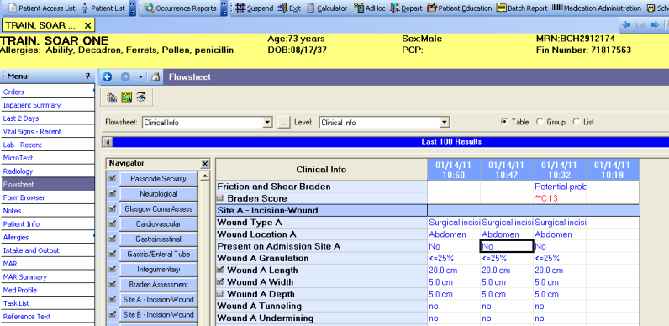

**Hint:** This is the Navigator Bar. When you click on a Section,

it will move to the top of the page for easier viewing.

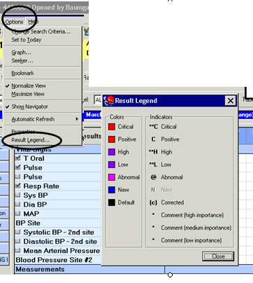

I’m not sure what the different colors indicate?

Find the **RESULT LEGEND**

Result Legend

1. Click on ‘Options’ on the tool bar
2. Choose ‘Result legend’

Graphing: At the end of your shift, check for incorrectly entered data; such as transposed vital signs, by graphing

1. First place check marks in the grey boxes in front the data you desire to graph.
2. Then click on the ‘Graph’ icon



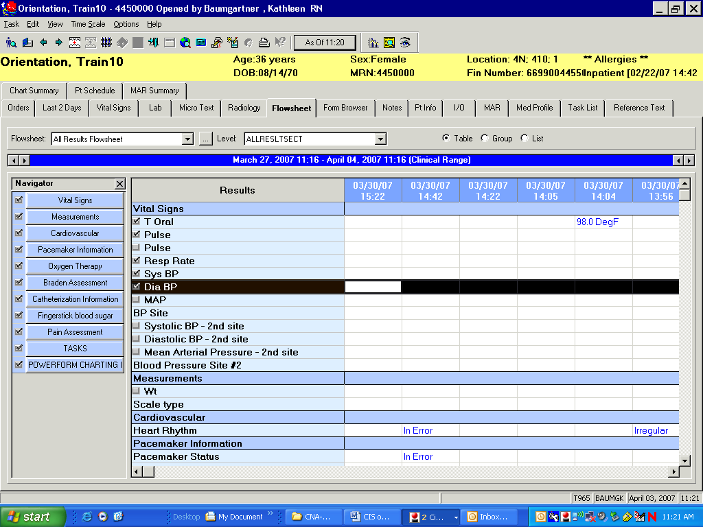

Graph Icon

-On the graph below, we see a heart rate of 16 bpm. We know the heart rate was actually 76 bpm.

-Go to the **Form Browser** and correct the error by modifying the appropriate form.

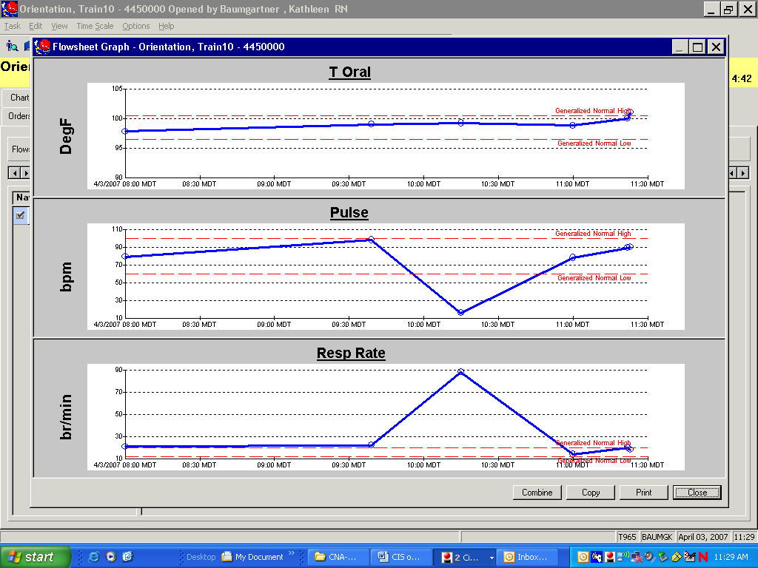

Red dotted lines indicate the high and low of the normal range

Form Browser: Utilize to correct charting errors.

Right click on the form you wish to work with.

Right click and set the Date Range Bar to the dates you desire.

## 

Choose one of these options.

End of Shift Duties:

* 1. It is your responsibility to deal with overdue tasks on the ‘Task List’ before leaving your shift.
  2. Clean up overdue and end of shift medications
  3. Graph vitals and weights
  4. Review fluid balance
  5. Correct charting errors

