Common Form Icons

ICON | Function
 | This icon will ‘Sign’ a completed form
This icon will ‘Save’ an unfinished form.
A ‘Saved’ a form will be marked as ‘in process’, so that you can complete it later from either the Task List or the Form Browse
 | This icon Cancels charting on open form.
Use this icon when you wish to ‘Erase’ or clear the screen that you are looking at.
It will not clear an entire form; it only clears one screen at a time when you click on it.
 | This icon on the task list indicates an incomplete form ‘in progress’
 | This icon will return a user to the main form if the documentation opens a secondary charting window.
 | This icon appears when required information is needed to be filled in
 | This icon appears when required information is documented
 | This icon means that information has ‘pulled forward’ from a previous charting session.
 | This icon indicates that ‘Reference’ material is available by right clicking in the box

Common Form Data Input Boxes
Typical Example | Description
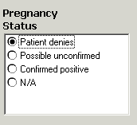 | Only one option can be selected
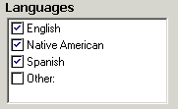 | Multiple options can be selected
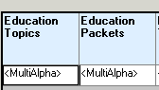 | Clicking on <MultiAlpha> to opens multiple options
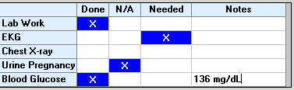 | Click on cell to place ‘X’ --Click again to remove
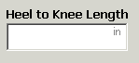 | Free Text
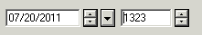 | Date/Time box.  Short cuts: ‘T’ for today and ‘N’ for Now

