Restraint CIS Order Entry
and Documentation

Restraint/Seclusion Order Entry………..…………..………. | Page 2
Restraint/Seclusion Order Renewal.……………………….. | Page 4
Restraint/Seclusion Tasks…………………..……………….. | Page 5
Restraint Assessment/Observation Form documentation | Page 6
Restraint Plan of Care ………………………………………… | Page 8
Accessing Restraint/Seclusion Forms via Ad Hoc....…… | Page 9
Discontinuing Restraints/Seclusion from Forms………… | Page 10

Restraint/Seclusion Orders:

IMPORTANT:
- Be sure to choose the correct type of Restraint Order
- Be sure the start time of the order reflects actual time of restraint/seclusion initiation
- Be sure that the discontinue time reflects the actual time of restraint/seclusion discontinuation
- When patients are transferred from the ED or from another Inpatient Unit, restraint/seclusion orders automatically discontinue. The patient must be reassessed on transfer and orders must be re-ordered if needed.
- If orders are not discontinued in a defined time frame, they must be renewed (based on patient assessment).

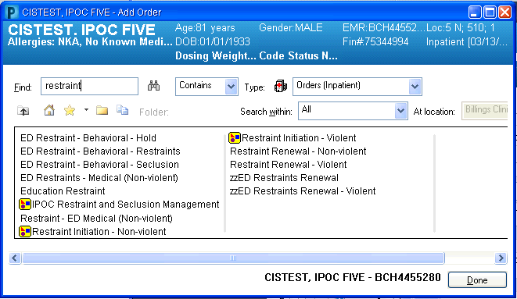

Inpatient Restraint/Seclusion Orders are built as a PowerPlan.

ED Restraint orders- Do not use. For Emergency Department use only

Restraint/Seclusion Orders: Entering Actual Start Time is Vital

IMPORTANT: Be sure to enter the actual start time of the restraint order

Orders need start time addressed
- Change start time on Initiation order
- Change start time on Assessment order
- Change start time on Observation order

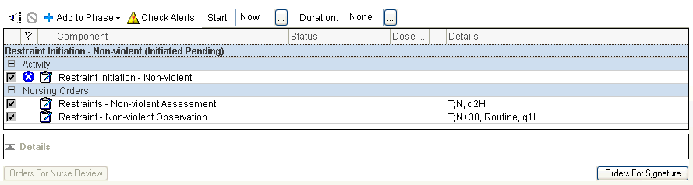

PowerPlan orders look like this

- Click Orders for Signature
- Adjust order start times (see screenshot below)
- Sign the Orders

Click on individual orders to enter details

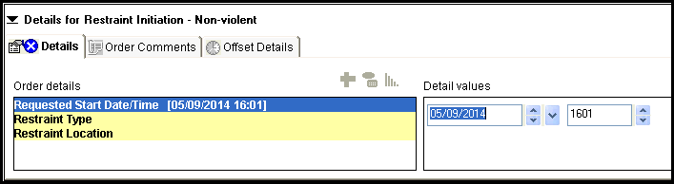

Enter Actual Start time here

Sign all orders

Restraint/Seclusion Order Renewal:

Important: If orders are not DC’d, they must be renewed

Renewal required for Non-Violent patients:
- Every calendar day regardless of age
Renewal required for Violent patients:
- Every 4 hours for ages 18 and older
- Every 2 hours for ages 9-17
- Every 1 hour for ages 8 and younger

Important:
Nurse will not order renewal for Non-Violent patients
- Provider required to do a patient face to face every calendar day so provider will renew order at that time
- Remind provider if order not renewed
Nurse may take a telephone order for renewal on violent patients
- Provider required to do a face to face every 24 hours, but, renewal orders are needed every 4 hours for adults
- Remind provider if order not renewed

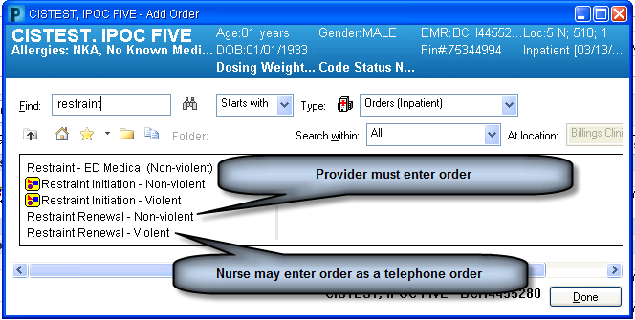

Restraint CIS Form Documentation

Restraint Tasks: Picking the Correct One is Important
Be sure to change the time to reflect the time that the observation was due.
- Electronic record must show that observation was done when the task was due.

Example:
- You have two tasks to chart-- one for 1015 and one for 1030.
- It is now 1045 and the patient condition is now such that you can to get to a computer to
chart your observational care.
- If you do not change the time it will appear that you did your observations at 1045 and 1046 rather than at 1015 and 1030

IMPORTANT: Be sure to choose the correct restraint task
Unlicensed Personnel may not fill out the ‘Assessment’ task
- Only RNs may complete the Restraint Assessment tasks
- Read the task description carefully
- Unlicensed staff & LPNs may only do the ‘Observation’ tasks

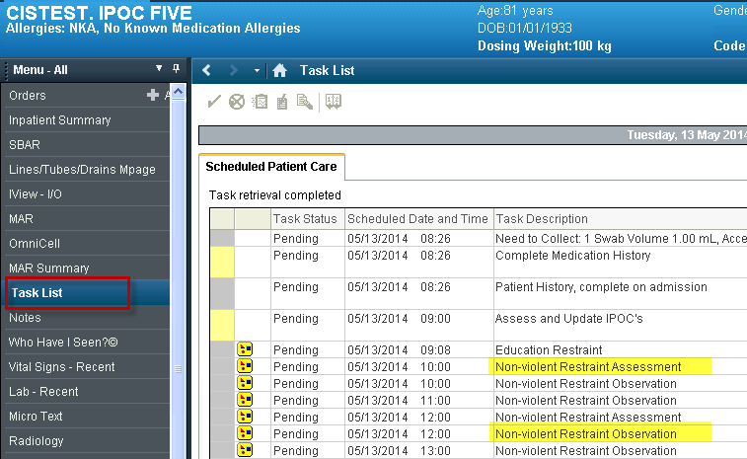

RNs will use this task (assessment)

CNA/MHW or nurse will use this task (observation)

Restraint Assessment/Observation Charting: Timing is Important

IMPORTANT: The time on the form must match the time of the task
Be sure to change the time on the form to reflect the time that the observation task was due.
- Electronic record must show that observation was done when the task was due.

Example:
- You have two tasks to chart-- one for 1015 and one for 1030.
- It is 1050 and the patient condition is now such that you can chart.
- If you do not change the time it will appear that you did your observations at 1050 and 1051 rather than at 1015 and 1030

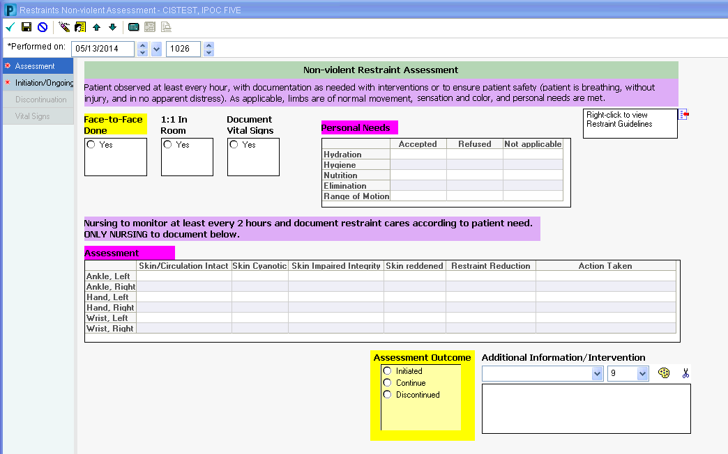

Change time here to match ‘task’ time

There are multiple pages to complete on Restraint Assessment Forms.

Anything in purple is information for you

Nurse decision about restraints goes here

Document Initiated with first assessment

Example of Non-violent Restraint Assessment Form

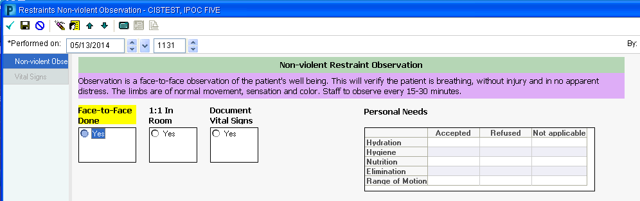
Change time here to match ‘task’ time
Example of Non-violent Restraint Observation Form

Restraint Assessment Charting: Page 2 (Initiation/Ongoing page)

IMPORTANT: If restraints are DC’d, then later re-initiated, the date/ time from the previous initiation will pull into the Restraint Initiated field. This must be updated.
The second page of the Violent and also the Non-Violent Restraint Assessment Forms is the Initiation/Ongoing page:
- Don’t forget to scroll down to view Guidelines in purple
- All yellow fields must be filled out prior to signing form. You will not be able to sign the form until these fields are filled in.

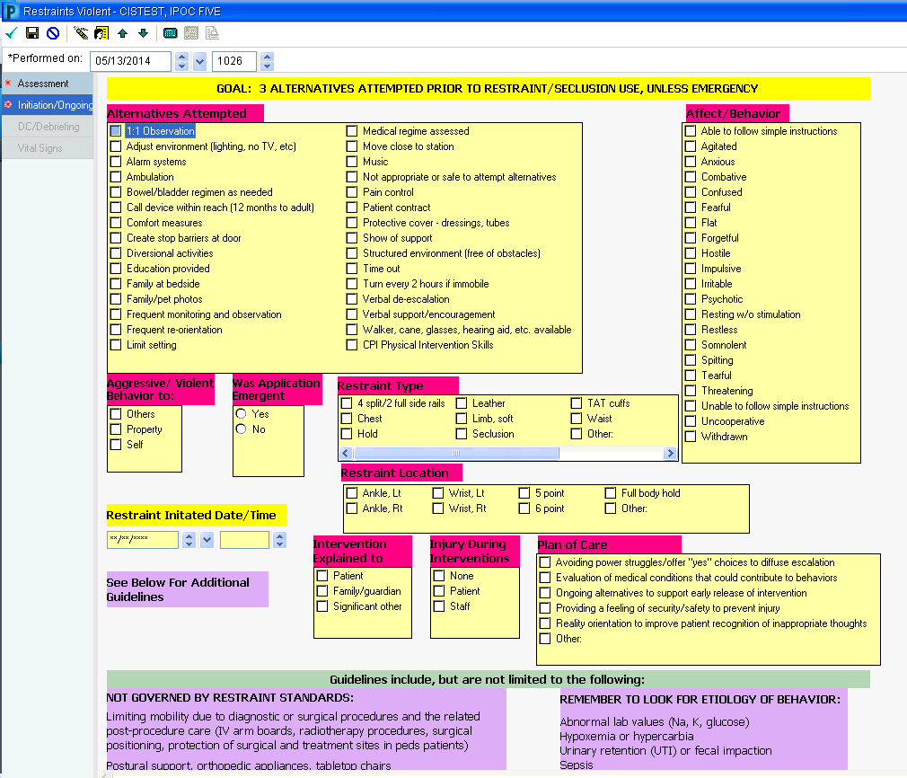

Fill out Initiation/Ongoing page with every assessment

- Be sure date/time entered here matches the time that restraints were placed
- This should also match the start date/time of the Restraint orders
- This date/time will pull forward the next time this form is filled out
- Be Careful! – If restraints are DC’d, then later re-initiated, the date and time from the previous initiation will appear here. Be sure to put in the current date/time in which the restraints were initiated.

Example of Violent Restraint Initiation/Ongoing Page

Restraint Assessment Charting: Page 2 (Initiation/Ongoing page)

IMPORTANT: The restrain Plan of care is included on the Form

There is no Restraint Interdisciplinary Plan of Care (IPOC). Plan of care for restraints is found on Page 2 of the form.
- Restraint plan of care needs reassessed and updated more frequently than IPOCs
- Restraint plan of care may change with each reassessment
- Short term care goal (need to remove restraints as soon as possible)

Complete and update with each assessment

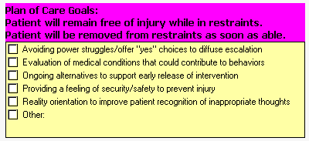

When the restraints are discontinued, the goals in the plan of care are met.
- See Discontinuation screen below
- Check the appropriate box(s)

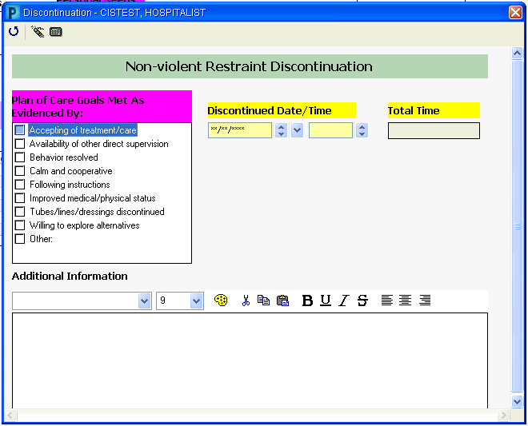

RESTRAINT/SECLUSION DOCUMENTATION--Nurses
Ideally the order is entered into the CIS system first and the form would be accessed via the task list.
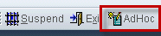
If the order is not placed in CIS, but you have already started the seclusion/restraint you may access the Restraints form from Ad Hoc charting.

1. Click on Ad Hoc

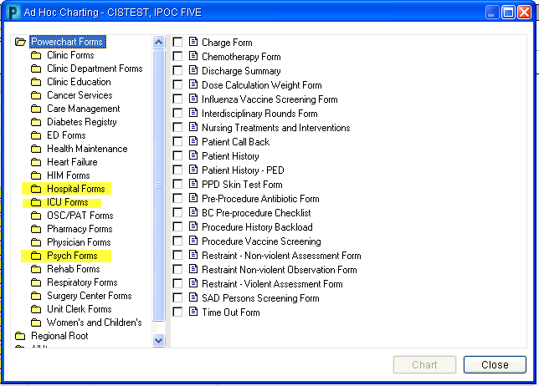

2. Open the folder that your area uses.

3. Choose form you need.

NOTE: If you access the forms from Ad Hoc you WILL NEED to address the tasks that will appear after the order is entered in CIS
- Document “Chart not done” with the reason free texted in “Did Ad Hoc”
- See example below.

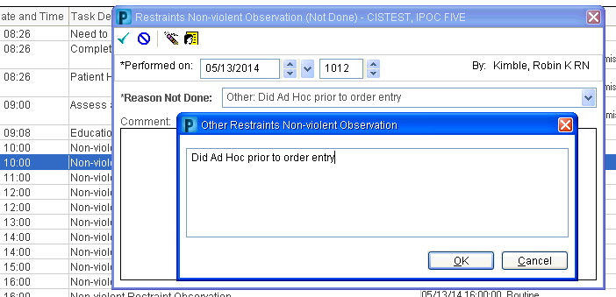

Free text the reason

RESTRAINT/SECLUSION DOCUMENTATION: Discontinuation

IMPORTANT: Accurate Time of Discontinuation is Vital

Restraint Discontinuation by Nursing
- Goal is to have patients restrained for the least possible amount of time
- If you determine restraints can be discontinued based on your nursing assessment, restraints can be DC’d without a physician order
- Marking Discontinue on the restraint assessment will generate an automatic system order to discontinue the restraint orders

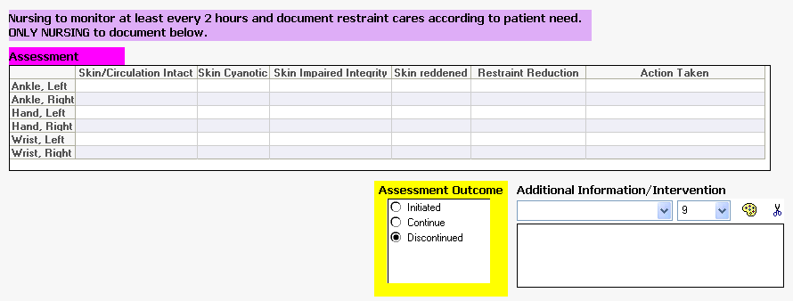
IMPORTANT:
If an injury occurs to the patient be sure to access the Risk Pro electronic occurrence reporting tool to document the occurrence.

Enter Actual time that Restraint/Seclusion ended
Fully complete both the Assessment and Initiation/Ongoing pages of the form when discontinuing restraints

Nurse assesses that the restraints be discontinued. Marking Discontinued will open the screen pictured below
This icon will return user to main page
Choose the most appropriate reason
The discontinuation reason will be on of these three choices:
Doctor Request
Not Needed

Patient Transferred

