**Pneumococcal Vaccination Education for**

**Hospital Nursing Staff**

Revisions to the Pneumococcal Vaccination Screening have changed the RNs responsibility for Screening on admission:

**STEP 1:** Prior to initiating vaccination screening make sure the following are assessed and correctly documented in CIS:

* Social history, particularly history of smoking and alcohol consumption
* Problem list
* Immunization history

**STEP 2:** Once these areas are correct, open the Pneumococcal Screening tool and complete the 3 circled items on the screening as indicated below:

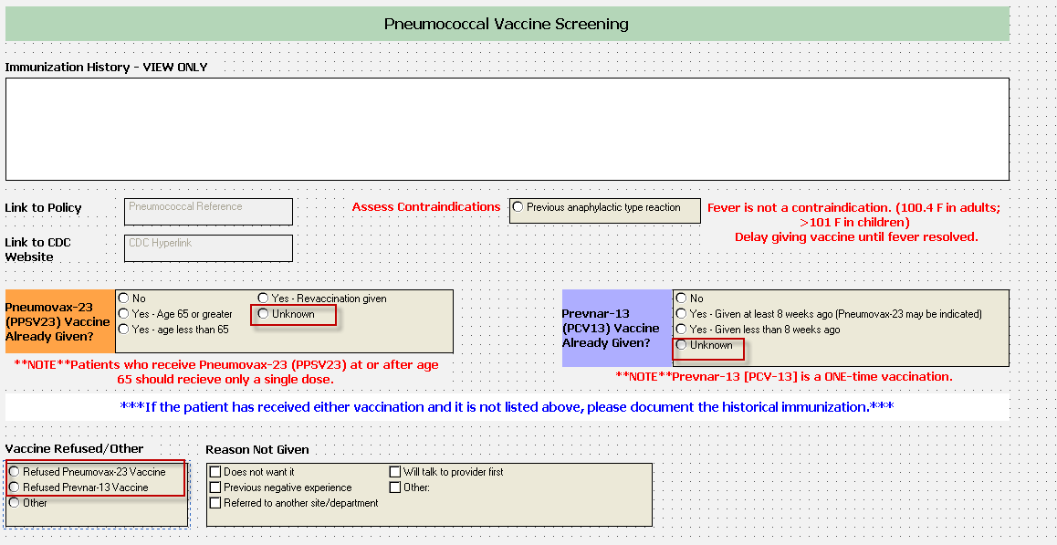

**Hint: if the patient received their vaccine before 2013 it was most likely Pneumococcal-23**

FOR CLINIC USE ONLY

**STEP 3:** Once this is completed work has been built in the background to look at multiple factors documented in CIS to determine the patient’s eligibility.

* If indicated, it will show on the patient’s MAR after pharmacy has verified.
* Vaccines are showing up as an unscheduled medication.

**STEP 4:** Once the indication for a pneumococcal vaccine type shows up on the MAR, review patient’s eligibility with them and inform them of what vaccine they are a candidate to receive.

* Provide VIS sheet prior to preparing injection and review with patient.
* Offer injection

**STEP 5:** Document outcome on MAR

* if they refuse, must indicate reason,
* pick from drop down on MAR (for all vaccine injections, flu also)

Refer to policy IC-114 for additional information. If you have any questions regarding the patient’s eligibility, contact the attending physician.