ED Quick Registration Conversation

Wheatland is a sample provided by Billings Clinic. The Quick Register all acts the same. Staff just needs to choose the appropriate fields like, “admit type/source, encounter type, medical service”, etc…This will provide a “cheat sheet” to help you through the process.

Definition: the ED Quick Registration was created to collect minimal patient information to perform a small registration. All ED Quick registrations will load to the incomplete worklist until a full registration is completed in the Register Patient Conversation.

Quick Tip: If a change is required to a completed ED Quick registration DO NOT use the Quick Reg conversation again to make the change. Make all registration changes to the ED Quick reg in the Register Patient Conversation.

Patient Search:
Search for patient using proper search criteria:
- Date of birth
- Partial Name- First 3 letters of last name, then comma space First two letters of first name, Example: WMH, JO
- Social Security Number
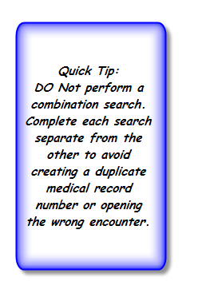
- Other name search
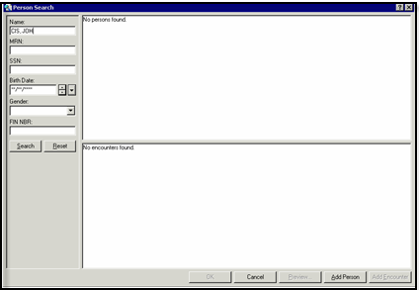

Search Continued….

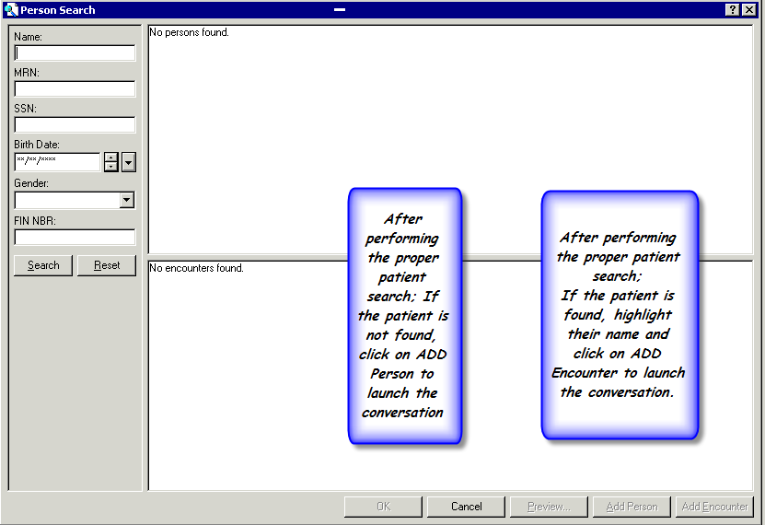

Facility Search
Search for and Highlight your facility and click ok

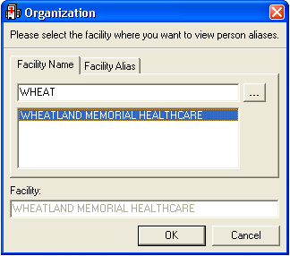

IMPORTANT!!!!!

Getting Started

These steps must be done prior to entering information in the fields and completing the conversation:
Right click within the conversation and select Highlight Required Fields
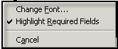
Make sure CAPS lock is on

Quick Tips

- Required fields will display in yellow

- Use Tab key to advance to next field & Shift key and Tab key at same time to go back to previous field. Try not to use your mouse

- Don’t click Complete until the end of the conversation

- Open at least two sessions of CIS registration. Once you have launched a conversation, you must do a complete registration. CIS does not allow saving partial conversations.
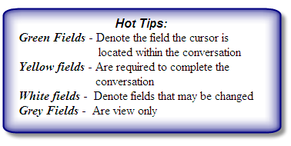

ED Quick Registration Conversation:
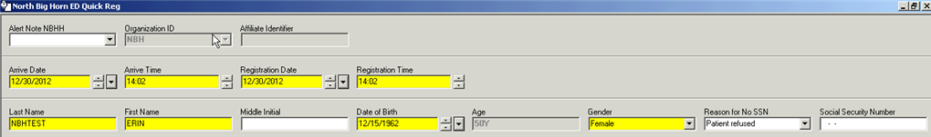

Alert Note:

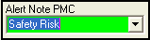

Alert Note-Select appropriate alert note from dropdown if applicable. If an alert is chosen then it will pop-up every time the patient’s record is accessed. To remove an alert just highlight the field and click on delete.
Bad Address or Phone Number | Duplicate Patient check Birth Date
BD, Collect at time of service | Need Valid SS#
Check Guarantor | Other – See Notes
Please Update Insurance | Privacy Issue
Release of Information Restriction | Safety Risk
Scheduling Restrictions See Notes | Special Needs See Notes
Testing Alert Note

Date & Time:

Arrival Date & Time – Will default to today and right now.

Registration Date & Time - Will default to today and right now. The Registration date and time will be the patient’s ED Admit date and time.

Basic Patient Information:

Patient Name Entering Tips –
- Always use the patient’s LEGAL name and follow the standards below. If you suspect the patient is using a nickname or their middle name, explain to the patient our need to register them correctly so we don’t duplicate a record.

- Last Name-Enter legal last name
- No spaces
- No punctuation
- No abbreviation
- Use all capital letters
- Names with an apostrophe are run together (O’Malley becomes Omalley)
- Native American names are run together (Goesahead)
- Hyphenated names are run together (Smith-Jones becomes Smithjones)
- Again use the name on the insurance card or ID if there is a question.

- First Name-Enter legal first name
  - If the patient uses their first initial and full middle name use this example (E Jane) place this all on the First name line.
  - It’s ok to have a space in a first name (Mary Ann)
  - Again use the name on the insurance card or ID if there is a question.

- Middle Initial-first initial of middle name
- Can only use the middle initial
- Leave blank if there is no initial
- Again use the name on the insurance card or ID if there is a question.

Basic Patient Information continued:

- Birth Date-Enter DOB in the following format: mmddyyyy

- Age field-view only field

- Gender-Select gender from dropdown

- Reason for No SSN-If no SSN available select appropriate reason. If provided leave blank

- SSN-Enter SSN-Leave blank if not provided

Address information:

- Address Line 1-Enter patient’s mailing address using standard postal format

- Zip code-Enter zip code which will populate the following fields:
  - City
Caution: If zip code has changed delete current zip code before adding new one.
  - State
  - Country
  - Area Code

- Home Phone Number-Enter home number
  - No phone- Enter all 1’s
Other Address info:
Patients who are homeless: Patients stating General Delivery:
Address Line 1: NO ADDRESS Address Line 1: General Delivery
Zip Code: 59047 Zip Code: Respective Zip Code

Published Patient List:

Confidentiality/Patient Directory: Ask if the patient would like to be listed on the Patient Directory. This means that they receive NO visitors or phone calls while in the Emergency Department if they choose not to be listed on the directory.
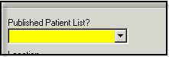

Photo ID Verified? – select Yes or No from the drop down. This is not a required field, but one that Billings Clinic is required to complete.
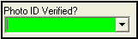
Location Section:

- Building – will default from beginning of conversation

- Nurse/Ambulatory – Will default

- Medical Service – Will default
- Admit Type – Will default

- Admit/Referral Source – Will default

- Patient Type – Will default in

- Attending & Admitting Physicians: Adding a physician into the Attending box will default the same physician into the Admitting box for you.

- If there is only one physician on duty, then use their name as admitting and attending.

- If there is more that one physician on duty then use the generic Emergency Room MD.

- Primary Care Physician - Complete
- Medical Record Number – If your patient does not have a current hospital medical record number one will automatically be assigned. This is a view only field.
- Financial Number – the patient’s visit number will be assigned automatically. This is a view only field.

To Select a Physician:

- To open the physician search, from the blank field "tab" (so that binoculars button is highlighted) then click on the "space bar".
- Type in the physician’s last name and hit enter to search
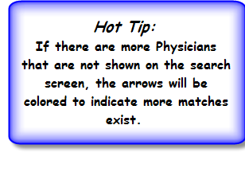
- Highlight the correct physician and click enter to load the physician into the conversation.
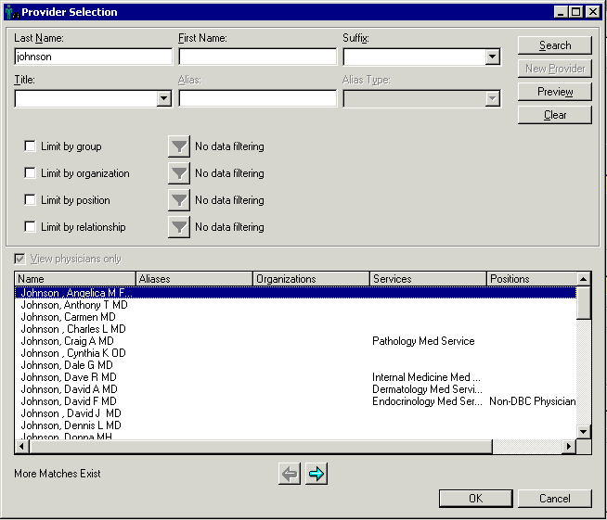

Patient Comments:
Here is where the person comments or notes are stored for the patient. If there is an Alert note that needs explanation, here is where the user needs to look for that information. You can place any note about the patient here. The patient comments are NEVER erased and will stay with the patient through all their encounters at Billings Clinic. Use proper grammar and spelling. The Users information will show if a note is added.

New Person Comments – Add a comment if appropriate

Previous Person Comments – view of all previous person comments, date of comment and who placed the comment in CIS

